Lab # 13

System Programming



Teacher | Bibi Areej Khan
Student Name | Muhammad Ahmad Khan
Registration No | 23JZBCS0238

Department of CS&IT
University of Engineering and Technology Peshawar
(Jalozai Campus)

Objectives
- To understand the concept of signals in UNIX/Linux.
- To learn how processes communicate using signals.
- To implement signal handling using SIGCHLD.
- To understand different waiting mechanisms such as pause(), sigsuspend(), and sigwait().
- To learn signal masking and synchronization between parent and child processes.

Theory
A signal is a software interrupt sent to a process to notify it that a specific event has occurred, such as the termination of a child process, a keyboard interrupt, or an illegal operation. Signals provide a simple form of communication between the operating system and processes.
When a signal is generated, it may be:
- Handled by a user-defined signal handler.
- Ignored using SIG_IGN.
- Processed using the default action (SIG_DFL).
Signals can also be blocked using a signal mask. A blocked signal is not discarded; instead, it remains pending until it is unblocked. This is different from ignoring a signal, where the signal is permanently discarded.
Important signal-related functions include:
- signal() – Installs a signal handler.
- sigaction() – Advanced method for signal handling.
- sigprocmask() – Blocks or unblocks signals.
- pause() – Suspends execution until any signal arrives.
- sigsuspend() – Safely waits for a signal while temporarily changing the signal mask.
- sigwait() – Waits synchronously for a specific blocked signal.
The SIGCHLD signal is automatically sent to the parent process whenever one of its child processes terminates.

Task 1: SIGCHLD Handler

Objective
Implement basic signal handling using SIGCHLD, where the parent waits for the child using a flag.

Code
#include <stdio.h>
#include <unistd.h>
#include <signal.h>
#include <stdlib.h>

volatile sig_atomic_t child_finished = 0;

void handler(int sig) {
printf("SIGCHLD received.\n");
child_finished = 1;
}

int main() {

signal(SIGCHLD, handler);

pid_t pid = fork();

if(pid == 0) {
printf("Child: running...\n");
sleep(2);
printf("Child: exiting...\n");
exit(0);
}

while(!child_finished);

printf("Parent: Child finished.\n");

return 0;
}

Compilation Command
gcc task1.c -o task1
./task1

Output

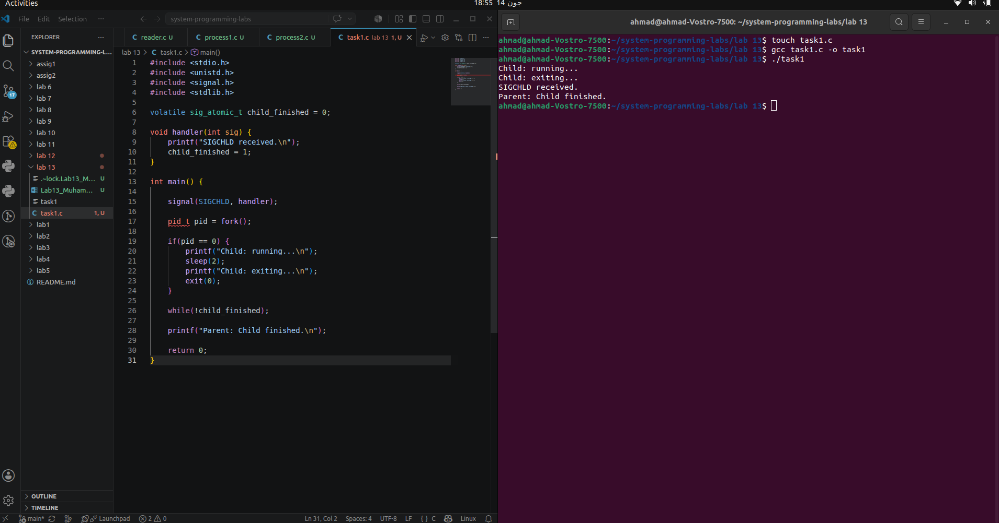
Task 2: Waiting Using pause()

Objective
Wait for the child process by suspending the parent using pause().

Code
#include <stdio.h>
#include <unistd.h>
#include <signal.h>
#include <stdlib.h>

void handler(int sig) {
printf("SIGCHLD received.\n");
}

int main() {

signal(SIGCHLD, handler);

pid_t pid = fork();

if(pid == 0) {
printf("Child: running...\n");
sleep(2);
printf("Child: exiting...\n");
exit(0);
}

pause();

printf("Parent: resumed after pause.\n");

return 0;
}

Compilation Command
gcc task2.c -o task2
./task2

Output

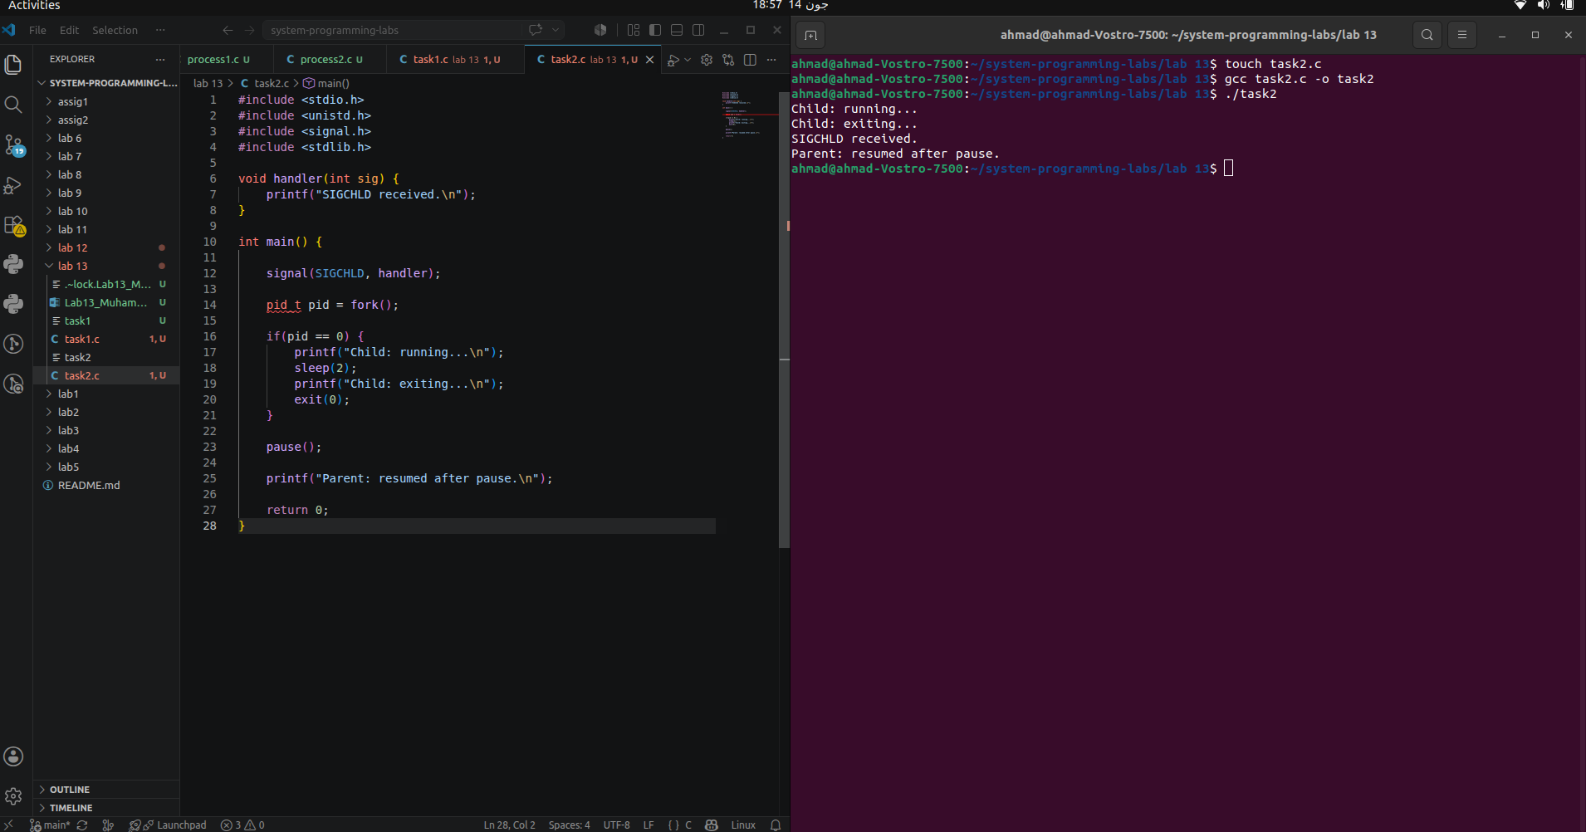
Task 3: Waiting Using sigsuspend()

Objective
Safely wait for the SIGCHLD signal while avoiding race conditions.

Code
#include <stdio.h>
#include <unistd.h>
#include <signal.h>
#include <stdlib.h>

volatile sig_atomic_t done = 0;

void handler(int sig) {
done = 1;
}

int main() {

sigset_t mask, oldmask, suspendmask;

signal(SIGCHLD, handler);

sigemptyset(&mask);
sigaddset(&mask, SIGCHLD);

sigprocmask(SIG_BLOCK, &mask, &oldmask);

pid_t pid = fork();

if(pid == 0) {
printf("Child: running...\n");
sleep(2);
printf("Child: exiting...\n");
exit(0);
}

suspendmask = oldmask;
sigdelset(&suspendmask, SIGCHLD);

while(!done)
sigsuspend(&suspendmask);

sigprocmask(SIG_SETMASK, &oldmask, NULL);

printf("Parent: Child finished.\n");

return 0;
}

Compilation Command
gcc task3.c -o task3
./task3

Output
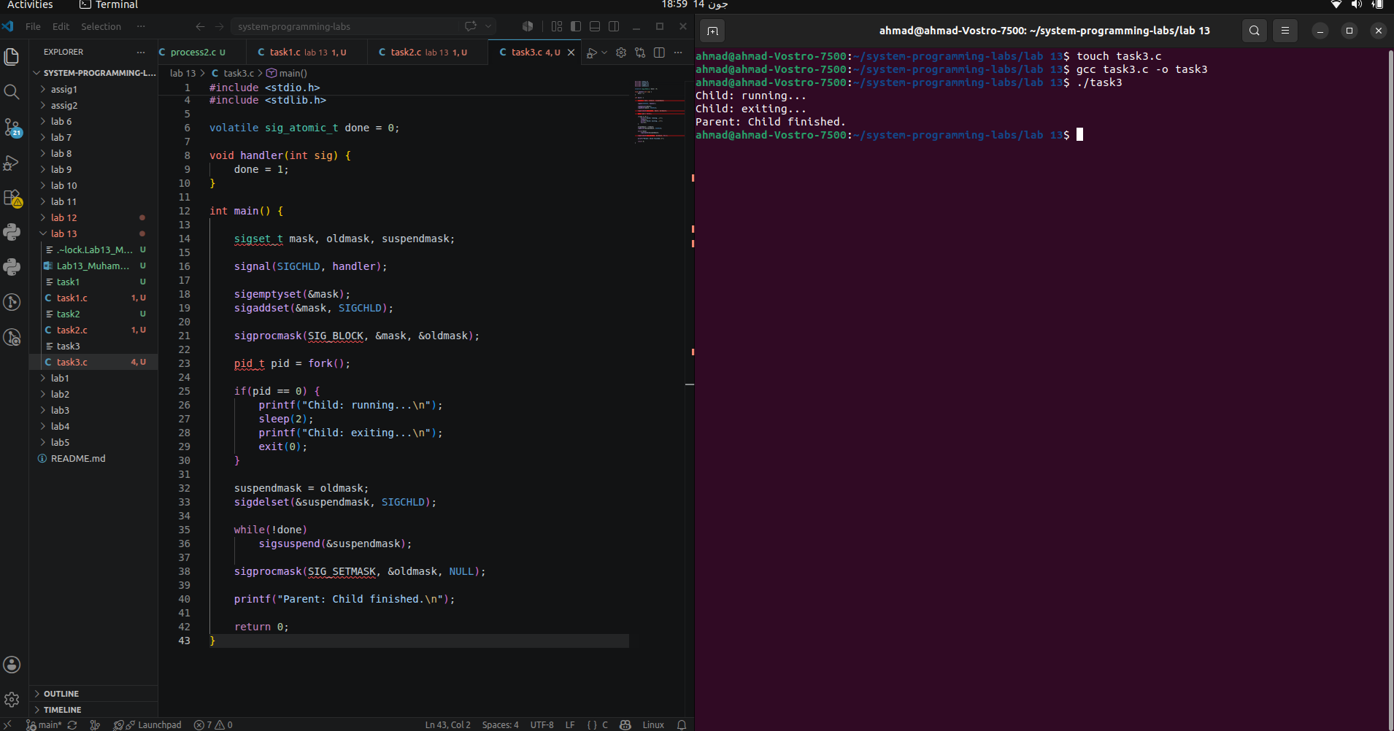

Task 4: Waiting Using sigwait()

Objective
Wait synchronously for the SIGCHLD signal without using a signal handler.

Code
#include <stdio.h>
#include <unistd.h>
#include <signal.h>
#include <stdlib.h>

int main() {

sigset_t set;
int sig;

sigemptyset(&set);
sigaddset(&set, SIGCHLD);

sigprocmask(SIG_BLOCK, &set, NULL);

pid_t pid = fork();

if(pid == 0) {
printf("Child: running...\n");
sleep(2);
printf("Child: exiting...\n");
exit(0);
}

sigwait(&set, &sig);

printf("Parent: SIGCHLD received (%d)\n", sig);

return 0;
}

Compilation Command
gcc task4.c -o task4
./task4

Output
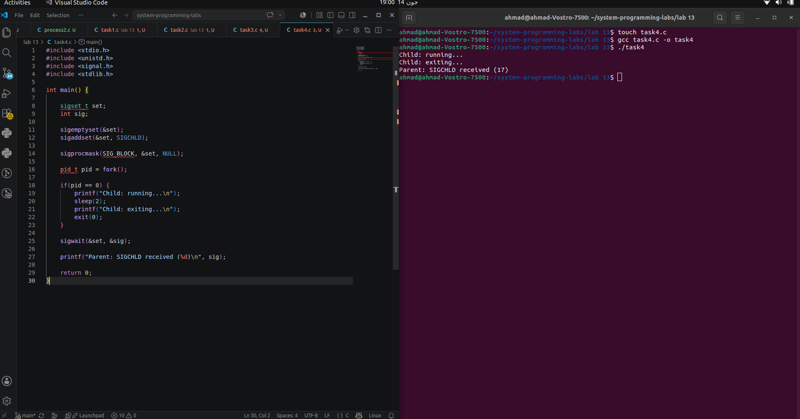

Conclusion
In this lab, we learned how signals are used for communication and synchronization between processes in UNIX/Linux. We implemented signal handling using the SIGCHLD signal and explored four different waiting mechanisms: busy waiting with a signal handler, pause(), sigsuspend(), and sigwait(). We also understood the importance of signal masks and how blocking and unblocking signals helps prevent race conditions. This lab provided practical experience in process synchronization and signal management in operating systems.

